****

Lab Task

Subject: Elementary Programming

المحاضر : علي إسماعيل مصطفي دوملو

اسم: عبد الحسيب جهيد

رقم الجامعة: 443058333

الجنسية: بنغلاديش

الجهة: الحاسب آلي

رقم الشعبة: 4476

Introductory Task

Part 1

Part 2

Part 3

Part 4

Part 5

Part 6

Answer to the Question No: 1

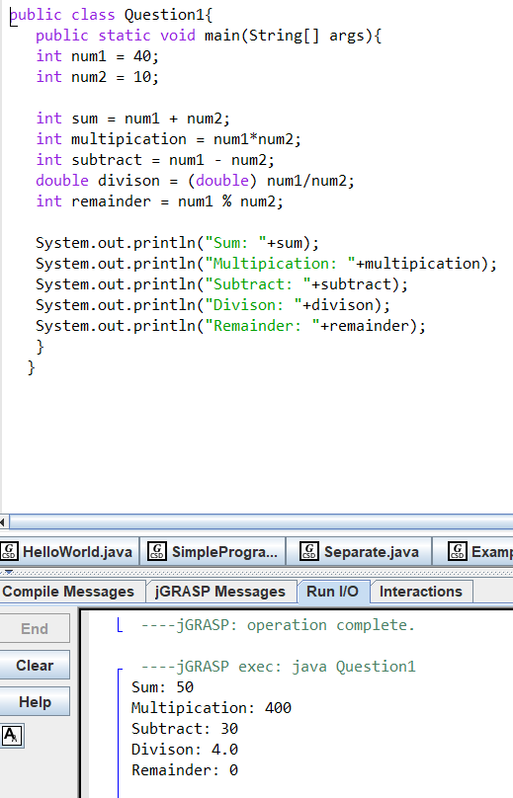

Answer to the Question No: 2

Answer to the Question No: 3

